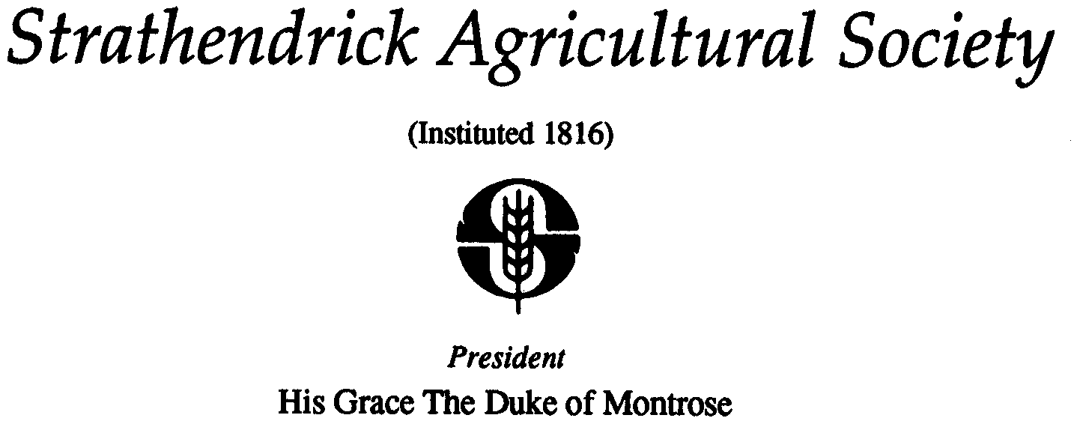

DATA PROTECTION – REQUEST TO STAY IN CONTACT

Strathendrick Agricultural Society would like to stay in contact with you. To comply with the new GDPR consent requirements, we need you to confirm that you would still like to hear from us.
We at Strathendrick Agricultural Society want to assure all our members and contacts that we handle your data professionally, securely and in accordance with these new regulations. (Please refer to our Privacy Policy on our web site www.drymenshow.com for more details.)
We currently hold your name and some contact details e.g. address, telephone number and email address. We use this information to send you details about events that the Society are holding and other Society matters. We do not sell your contact data or pass on any details without your consent. We are not intrusive with our communication and hope we can stay in touch.
We would be grateful therefore if you could complete and return the form below by post (Secretary, Strathendrick Agricultural Society, Keirhill Farm, Balfron, G63 OLG) or email (david.keirhill@btconnect.com) to confirm you are happy for us to stay in contact with you and to ensure if you are that we have your most up to date contact details.
Unfortunately, if you do not confirm we will no longer be able to contact you.

THANK YOU FOR YOUR SUPPORT

CONTACT 1:

REQUIRED FIELD – NAME

REQUIRED FIELD – EMAIL ADDRESS:

OPTIONAL FIELD - TELEPHONE / MOBILE NUMBER:

OPTIONAL FIELD - EMAIL ADDRESS:

CONTACT 2:

REQUIRED FIELD – NAME

REQUIRED FIELD – EMAIL ADDRESS:

OPTIONAL FIELD - TELEPHONE / MOBILE NUMBER:

OPTIONAL FIELD - EMAIL ADDRESS:

