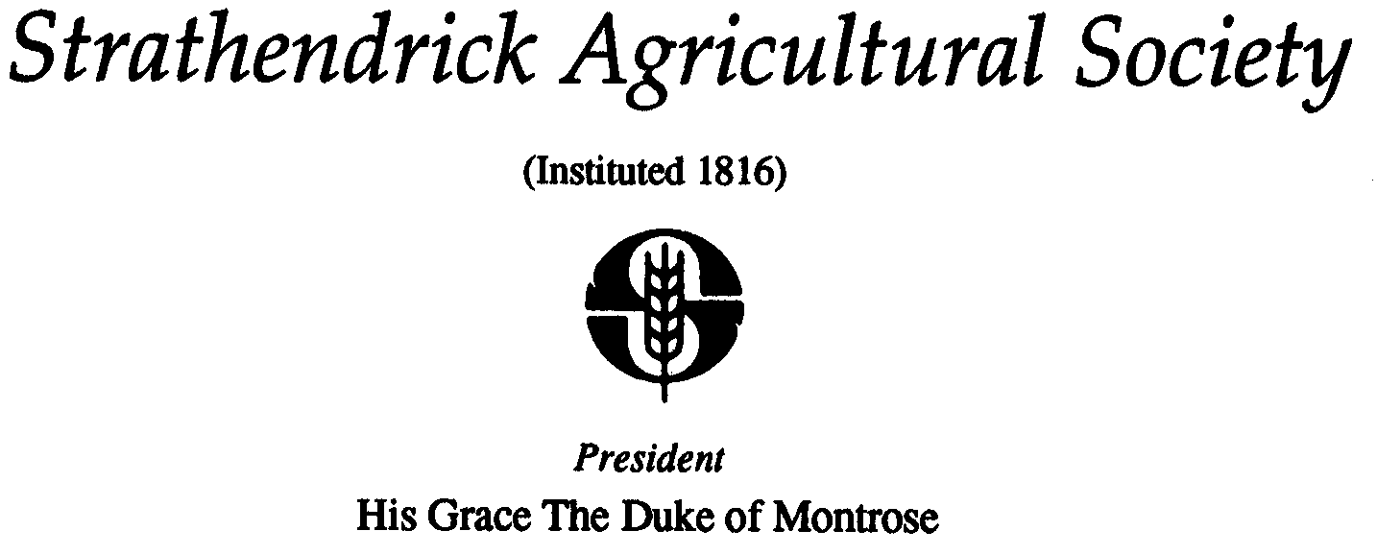
DRYMEN SHOW MEMBERSHIP

Convenor: Rosie Allan
Address: 7 Crietyhall Road, Milton Of Buchanan, Drymen, G63 0JA
Tel: 07899807601
Email: connich9@gmail.com

Many thanks for considering becoming a member of Strathendrick Agricultural Society, which hosts Drymen Show.

If you have any questions regarding your membership at any time please contact Rosie Allan, membership convenor, on the details above or our Secretary David Steel on 01360440612, 07796867100 or david.keirhill@btconnect.com

MEMBERSHIP ENTITLEMENTS:
- Free entry to show by Member’s Badge provided
- Membership for calendar year
- Ability to attend and vote at AGM
- Ability to exhibit in any Agricultural Class where membership is required to enter
- If exhibiting in an Agricultural Class and entered 1 week prior to show day, an additional 2 free entry passes

MEMBERSHIP CHARGES:
- Adult Membership £10.00
- 13 -17 years old (age at date of payment) £5.00
- 12 years and under £2.00
- Life Membership £250.00

MEMBERSHIP PROCESS:
- Please complete your details below and email or post to Rosie Allan along with payment
- Payment can be made by cheque made payable to ‘Strathendrick Agricultural Society’ or BACS using these details. Bank: RBS. Account name: Drymen Show. Account number: 00255208. Sort Code: 83-17-39
- If paying by BACS please enter your name and membership 2021 for reference and let Rosie Allan know payment has been made

Membership Type: Please circle ADULT 13-17 12 & UNDER LIFE
Name:

Address:

Post Code:

Tel/Mobile:

Email:

Charge: £

I ENCLOSE A CHEQUE FOR £ _______ (payable to Strathendrick Agricultural Society)

I HAVE MADE A BACS PAYMENT FOR £_______ (please reference on BACS payment name and “MB” )

AGREEMENT TO BE CONTACTED BY STRATHENDRICK AGRICULTURAL SOCIETY TICK FOR CONSENT

