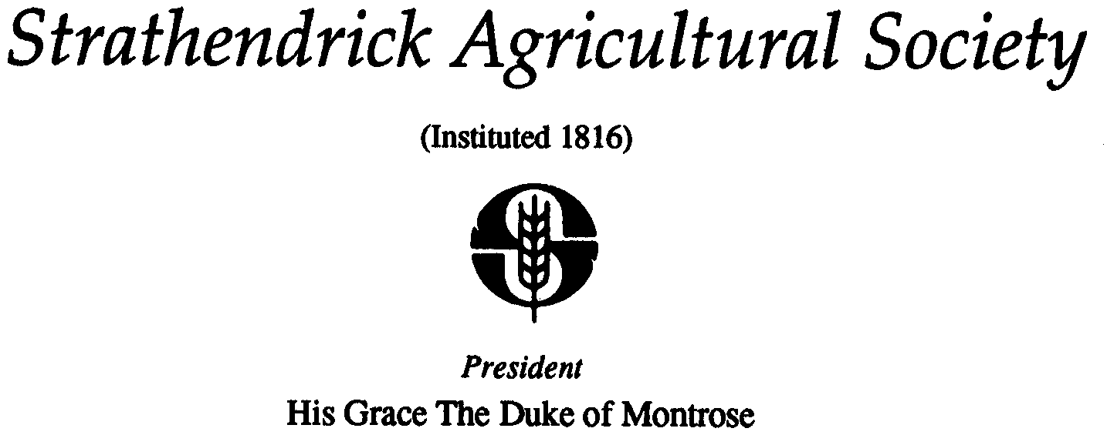
DRYMEN SHOW MEMBERSHIP

Convenor: Rosie Allan
Address: 7 Crietyhall Road, Milton Of Buchanan, Drymen, G63 0JA
Tel: 07899807601
Email: connich9@gmail.com or drymenshow@outlook.com

Many thanks for considering becoming a member of Strathendrick Agricultural Society, which hosts Drymen Show.
Please ensure you tick the box at the bottom of the form to confirm you are happy for us to stay in contact with you in line with new GDPR requirements.

If you have any questions regarding your membership at any time please contact Rosie Allan, membership convenor, on the details above or our Secretary David Steel on 01360440612, 07796867100 or drymenshow@outlook.com

MEMBERSHIP ENTITLEMENTS:
- Membership for a calendar year covering the show itself and the Society’s AGM
- Notification & Minutes of the Society’s AGM
- Ability to attend, contribute towards Office Bearers and Judges and to vote on any matters raised at the Society’s Annual General Meeting held in Nov each year
- Ability to exhibit in any Agricultural Class where membership is required to enter
- Free entry to the show by way of a Member’s Badge provided
- If exhibiting in an Agricultural Class and entered 1 week prior to show day, an additional 2 free entry passes

MEMBERSHIP CHARGES:
- Adult Membership £10.00
- 13 -17 years old (age at date of payment) £5.00
- 12 years and under £2.00
- Life Membership £250.00

MEMBERSHIP PROCESS:
- Please complete your details below and email or post to Rosie Allan along with payment
- Payment can be made by cheque made payable to ‘Strathendrick Agricultural Society’ or BACS using these details. Bank: RBS. Account name: Drymen Show. Account number: 00255208. Sort Code: 83-17-39
- If paying by BACS please enter your name and membership 2022 for reference and let Rosie Allan know payment has been made

Membership Type: Please circle ADULT 13-17 12 & UNDER LIFE
Name:

Address:

Post Code:

Tel/Mobile:

Email:

Charge: £

I ENCLOSE A CHEQUE FOR £ _______ (payable to Strathendrick Agricultural Society)

I HAVE MADE A BACS PAYMENT FOR £_______ (please reference on BACS payment name and “MB” )

AGREEMENT TO BE CONTACTED BY STRATHENDRICK AGRICULTURAL SOCIETY TICK FOR CONSENT

