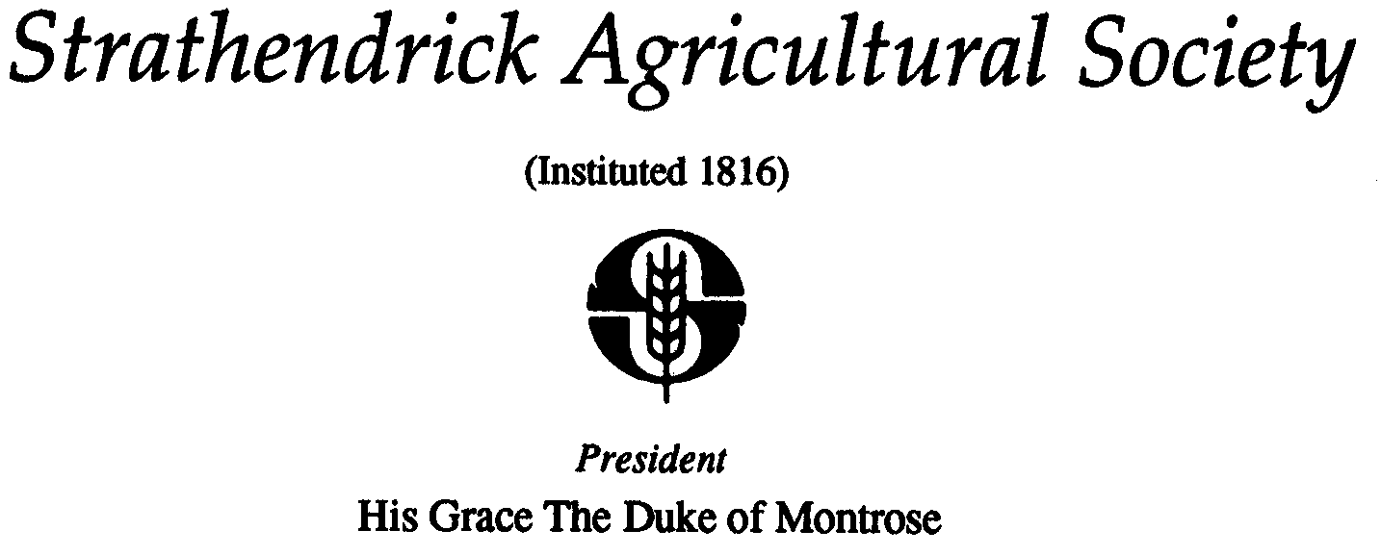
PRIVACY NOTICE

About Strathendrick Agricultural Society

Strathendrick Agricultural Society is a UK registered charity (no. SC042565) dedicated to the advancement of citizinship and community development, and through holding an annual agricultural show and other events relating to agricultural and country interests and pursuits, educate and advance heritage and culture within the area and environs of Strathendrick, regarding livestock breeding and animal husbandry.

Our commitment to you

To enable us to undertake our charitable objectives we collect and use personal information about individuals.
We recognise the trust placed in us by individuals whose information we use. It is important to us that we are open and honest about the way we use information and we are committed to ensuring that we do so in a manner that is both lawful and respects your privacy. This notice applies to the general public and our members, supporters, employees, volunteers, contractors, and service users. The lawful basis for processing the data is contractual. This privacy notice sets out the details about how we collect, use and look after information (known as processing) and what you can expect from us. This privacy notice is designed with clarity in mind and does not provide extensive detail of every aspect of how we collect and use your personal information. You can access and request specific details or clarification by contacting us using the contact details in this statement.

Contents

This privacy notice provides details about:

• Your rights as an individual
• Contacting us about your information
• The information we collect and use
• Why we share information about you
• How long we keep information about you

Your rights as an individual

We feel it is important that you are aware of your rights as an individual.

• The right to be informed: You have the right to be told about how and when your personal information will be used. Our aim is that this notice, in conjunction with statements on other materials, provides a clear and transparent description of how your information will be used.
• Right of access: You have the right to request a copy of the information that we hold about you (this is also known as a ‘Subject Access Request’).
• Right of rectification: Yu have a right to correct data that we hold about you that is inaccurate or incomplete.
• Right to be forgotten: In certain circumstances you can ask for the data we hold about you to be erased from our records. You should be aware we are required to keep most information for a minimum period of time.
• Right to restriction of processing: Where certain conditions apply you have the right to restrict our processing of your information.
• Right of portability: You have the right to have the data we hold about you transferred to another organisation.
• Right to object: You have the right to object to certain types of processing such as direct marketing.
• Right to object to automated processing including profiling: You have the right to ensure decisions about you are not automatically made by a system or technology.

In the first instance you should contact us about your rights and how we use your information. You are entitled to an independent review of our actions should you have a concern or feel we have not respected your rights.

If you feel this is the case, you can register your concern with the UK Information Commissioner’s Office. Details on how to do so can be found here on their website (https://ico.org.uk/concerns) or by calling 0303 123 1113.

Contacting us about your information

As part of our responsibilities for looking after your information our Secretary is responsible for ensuring we fulfil our obligations and commitments.

At any time you may contact us about us about any matter relating to your information. To assist us in providing you with the most appropriate response we provide a number of ways you can get in touch as follows:

How you can get in touch

For general enquiries, to update or change your choice of communications you receive from us or to register a complaint or concern about how we use your information and to exercise your rights in relation to:

• Accessing your information
• The right to be forgotten
• The right to restrict/ object to processing
• The right to data portability

Email: david.keirhill@btconnect.com
Post: D. Steel, Keirhill Farm, Balfron, Glasgow G63 0LG
Phone: Tel: 01360 440612 / Mobile: 07796 867 100

You must include sufficient information to let us identify you and details about which rights you are exercising.

The information about you we collect and use

It is important to us that we inform you about the information we collect and why we collect it.

Information is predominantly used to communicate with you and to enable Drymen Show to be held each year and may be related to one or some of the areas below, although this is not extensive.

  - Membership of the Society
  - Volunteering for the Society
  - Exhibiting at Drymen Show
  - Judging at Drymen Show
  - Promoting Drymen Show
  - Educational aims of the Society
  - Sponsorship & Supporting the Society

There are times when it is not practical or feasible for the Strathendrick Agricultural Society and its related undertakings to obtain or record consent, however this information will only be used or processed if there is a legitimate interest for us to do so, and in doing so your interests and rights as an individual are not harmed.

You can update your preferences at any point by contacting us via the details above.

As a charitable organisation we also hold, and process data as required by regulatory bodies such as the Charities Commission. This can include personal information relating to:
• Enquiries or complaints about us.
• Processing financial transactions, maintaining our accounts and prevention of fraud.

Our website may also contain links to other websites or services. You should note that we are in no way responsible for the content or privacy policies these websites / services may have in place and advise that you use caution and refer to these websites own Privacy statements and terms.

Why we share information about you

We understand that sharing information is a sensitive topic. We will never sell your information and are committed to being transparent with you about where we legally share information, the reason why and who with.

The list below provides an overview of what information is shared and with who.

We share information for the following reasons:
• Personal information with professional bodies and regulators in accordance with our statutory obligations.
• Personal information with Affiliations and Societies where relevant, as well as DEFRA in accordance with our statutory obligations.
• Limited information about your digital identity is used to provide statistical information about the use of our IT systems including website and social media pages.

How long we keep information about you

We only keep information for as long as we are allowed to in accordance with other legislation or relevant regulations.

Once we no longer need to keep your information we remove it from our systems or securely dispose of it and we do this at the end of each financial year.

• Staff and volunteer records are kept for ten years after they leave.
• Member & supporter records are kept for ten years after the date of the last donation.
• Details about legacies we receive are kept for 12 years and details about legacy pledges are kept indefinitely.
• Information about financial transactions including supplier/ customer information is kept for seven years.

Notification of changes

This statement may change from time to time, for example, if the law around information changes or for operational purposes. We advise you to visit this page regularly to keep up to date with any changes

