Section 3 - Young Artist
Group 1: P1 and P2 A drawing or painting using any
Group 2: P3 and P4. medium size of work not to
Group 3: P5 and P6 exceed A3. Mounting to be
Group 4: P7 Kept to a minimum.

Section 4 - Young Crafters
Group 1: P1 and P2 Individual or group work
Group 2: P3 and P4 displaying skills using any type
Group 3: P5 and P6 of materials and techniques.
Group 4: P7 Size of display not to exceed 1m x 1m.

Section 5 - Design Next Year’s Front Cover
- Open to all ages.
- Design the front cover for next years programme. Not to exceed A4
Section 6 - Working Together
- Open to all ages.
- A piece of work that has been completed by a group of children. This could be a frieze, model or perhaps a display which shows the children’s learning. The kind of thing we see in the classroom everywhere!

We’d like to encourage as many children to take part as we can. The school’s tent is always a star attraction at the Drymen show. It is a great opportunity to share the wonderful things being achieved in our schools with the wider community.

Strathendrick Agriculture Society

(Instituted 1816)

President
His Grace The Duke of Montrose

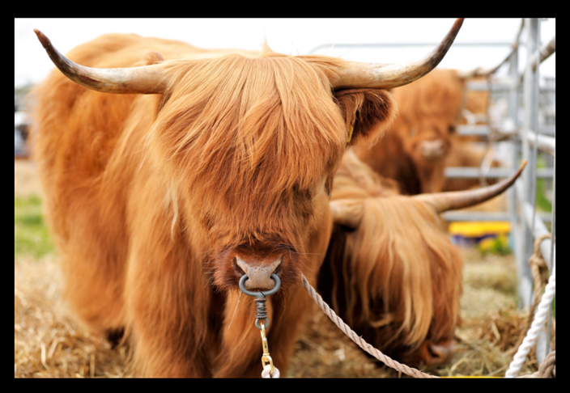

School competition Rules

Drymen Show 2023
Saturday 27th May 2023

- All schools may enter a maximum of 4 entries per group. If preferred, schools may submit one class entry in pace of individual entries in any class/group that seems appropriate.
- SCHOOLS ARE ASKED TO TAKE NOTE OF DISPLAY SIZES (as we are limited with space available).
- The schools’ tent provides an exhibition of some of the best creative work of pupils from schools in the area.
- All schools and nurseries participating will receive certificates.
- Rosettes will be awarded by the judges for work judged to be outstanding.
The judges. Decisions are final.
- IMPORTANT ADVICE FOR ENTRIES: All entries must be clearly and securely labelled using the labels provided stating name/age/school/exhibition section and group. The label must be folded shut and attached to the exhibit. No other means of identification should be visible.
NURSERY CUP Gifted by Park Life Magazine
This cup is awarded to the winner of the Nursery Section.
STRATHENDRICK SCHOOLS CUP Gifted by Loch Lomand Homes & Garden Centre.
This cup is awarded for the best entry in Section 1.
DR BRIAN KEIGHLEY SHIELD Gifted by the Keighley Family
This Shield is awarded for the best entry in Section 2.
SCHOOL SHIELD Gifted by Balfron Health Centre
This shield is awarded for the best entry in Section 3.
STRATHENDRICK SCHOOLS SHIELD Gifted by Mr & Mrs W Alexander.
This shield is awarded for the best entry in Section 4.
CUP – Champion of champion

Entries for the YOUNG WRITER, POET and ALL WRITTEN WORK in section 5 will be collected on 10th May 2023. All other entries will be collected from schools on 24th May 2023.
The exhibition will be open from 10.00am – 3.00pm on Saturday 27th May when we look forward to meeting the entrants and families. Whilst every effort is made to look after exhibits whilst on the show venue, the committee cannot be held responsible for any damage to exhibits. Please note that judging will take place on Friday 26th May.
All enquiries regarding the Schools Competition should be made to the School Convener on 07873 402456 or by email to donnam121@googlemail.com
Nursery Section
One frieze, own choice of subject, work of the children.
ENTRY MUST NOT EXCEED 2m x 1m. TABLES WILL BE SUPPLIED FOR MODEL USE ONLY.
Section 1 - Young Poet
Group 1: P1 and P2 Any poetry writing
Group 2: P3 and P4 Work may be in child’s
Group 3: P5 and P6 handwriting, or word processed.
Group 4: P7. Mounted work not to exceed A3.
Section 2 - Young Writer
Group 1: P1 and P2. Any prose writing not exceeding
Group 2: P3 and P4 500 words
Group 3: P5 and P6 work may be in child’s
Group 4: P7 handwriting or word-processed.
Mounted work not to exceed A3.

