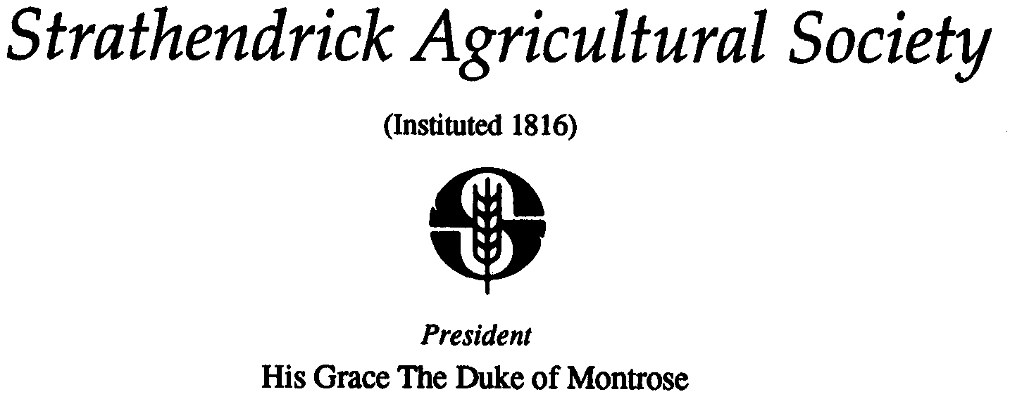
Secretary: Keirhill Farm Balfron Glasgow G63 0LG
Tel: 01360 440612 Mobile: 07796 867100

Email: david.keirhill@btconnect.com

February 2023

Dear Sir / Madam

DRYMEN SHOW – SATURDAY 27TH MAY 2023

Please find attached / enclosed a Booking Form, Risk Assessment Form and below our Trade / Craft Stand regulations for the above show.

You can enter by post or on line at https://drymenshow.lite.events.

Charges for trade stands in 2023 will be a minimum of £50 for a 3 metre frontage x 6 metre depth trade stand. Additional frontage is charged at £15 per metre. Additional depth is free of charge but subject to availability.

Charges for craft stands in 2023 will be £45 for a 2 metre x 2 metre slot, which includes a 1.8 metre (6ft) table and 2 chairs.

Applications with all relevant paperwork and payment should be returned to the relevant convenor and made by Saturday May 13th latest to guarantee a slot.

Please note that
- catering concessions have already been allocated and no further trade stands / craft stalls which fall into this category can be accepted unless otherwise agreed by the Secretary.
- for any stands running tombolas etc you will need to apply for a licence from Stirling Council and you must comply with their licencing regulations.
- if you are planning to have noise on your stands during the day please complete the relevant part on the form. This is essential information when it comes to positioning the trade stands.
- Only craft stands can be accepted in the craft tent unless otherwise agreed with convenor
- Maximum of 33 craft stand spaces available

There are prizes for the best presented Trade Stand and Craft Stand. These shall be judged and prizes presented on the day of the show.

Drymen Show also gives one charity a complimentary trade stand at Drymen Show. If you wish to be considered please have your charity stands booked by the 13th May deadline, when one will be selected and have their payment refunded.

We look forward to welcoming you to another successful show.

Sincerely,

David Steel
Secretary

DRYMEN SHOW TRADE AND CRAFT STAND
REGULATIONS

Coronavirus (Covid-19 & Variants)

Please refer to any to Scottish Government guidance applicable at Coronavirus in Scotland - gov.scot (www.gov.scot) before attending the show. It is the responsibility of the craft/trade stand holder to adhere to the guideline requirements at the time of the event (Drymen Show).

Necessary actions advised within the guidance at the time of applying for the show should be indicated within the risk assessment form provided with your application and adjusted, if required due to changing guidelines, for the day of the show.

Strathendrick Agricultural Society will also follow any government guidelines, and those specifically advised for outdoor events of our size with tents.

Craft stand applicants must therefore be comfortable if additional panels are opened in the tents to allow more air circulation as well as if tents are secured more tightly due to weather, if regulations allow. All tents will have hand sanitisation stations outside and clear signage recommending the use of face masks, although this cannot be policed.

SPACE PROVIDED:

External Trade Stands - Available Space:
Stand space is provided at a minimum of 3 metres wide / frontage by 6 metres deep. Trade Stand Holders requiring additional width or depth must note this on their application. Please note that areas where additional depth can be achieved are limited and will be accepted on a first come first serve basis.

Internal Craft Stands – Available Space:
Craft stands are calculated in 2 metre slots with a 1.8metre (6ft) table and 2 chairs provided.

APPLICATIONS AND PAYMENT:

Applications can be made using the official forms with all details completed as requested and signed or on our on line Entry System https://drymenshow.lite.events.

If applying using forms they must be returned with full payment (either with cheque included or confirmation that BACS payment has been made) and all required documentation by the stated date.

Cheques are to be made payable to ‘Strathendrick Agricultural Society’.

Payment can also be made by BACs; Account Name: Drymen Show, Account Number: 00255208, Sort Code: 83-17-39.

Please note if paying by BACS it is essential that you write the name, or your trade / craft stand and or your name in the reference section to allow us to know if you have paid or not.

Unless advised otherwise all fully paid stands which have submitted all the required documentation can be taken as confirmed and accepted.

In the event of cancellation by an applicant, the applicant remains liable for the full amount.

If Drymen Show is postponed or cancelled due to circumstances out with our control all stands monies will be transferred to the rescheduled date. A full refund will be made to any stands for which the new date is not suitable.

POSITIONING:

Applicants must state on the application form / on line application what they propose to exhibit/sell (eg , jewellery, clothing, plants, furniture etc) and whether there will be excessive noise levels e.g. (balloons, paint ball, music etc).

This information will help us allocate the best positioning of trade and craft stands and ensure any stands with excessive noise are not situated close to livestock.

Please note the positioning of Trade Stands is at the absolute discretion of the organisers (but consideration will be given to requests) and any activity deemed to be emitting excessive noise will be stopped at the discretion of the Society committee.

Please note Craft Stands will be advised of which tent (if more than one) they will be in but thereafter it is a first come, first served basis in terms of which slots / tables are available.

OTHER CONDITIONS:

External Caterers are appointed by the Society which has the sole catering rights at Drymen Show. Applications for mobile hot or cold food units, ice cream vans or mobile bars shall not be accepted unless by prior arrangement with the Secretary.

Stand holders may not distribute handbills, leaflets or posters out with the stand space.

The sale of spray string or any other similar product will not be allowed at Drymen Show.

The Society committee reserve the right to take whatever action is deemed necessary if the above instructions are disregarded.

The Society respectfully requests also that the use of single use plastic is avoided or limited.

VEHICLE PASSES AND ENTRY TICKETS

Each trade and craft stand will be issued with 1 vehicle pass and 2 entry passes.

For trade stands which pay for a larger frontage than the minimum 3 metres, additional passes may be requested on the application form and will be awarded at the discretion of the convenors in line with the size of stand being taken.

Vehicles/people without passes will NOT be permitted entry to the site unless entry charges are paid at the gate.

Stand holders are responsible for providing their members of staff, where applicable, with the necessary tickets.

Tickets will be sent out in May by post to the address on the application form.

If all paperwork and payment has been made by the closing date of May 13th, any stand holders not receiving their passes by Sat 20th May should contact the trade / craft stand convenors or show secretary.

No free passes or tickets will be issued on site and no refunds will be made to stand holders, their staff or representatives who have arrive at the Showfield without their tickets/passes thus paying public prices to gain admission to Drymen Show.

SITE PREPERATION AND CLOSING DOWN:

Contractors:
Stand holders are permitted to employ their own contractors to supply and erect tents, marquees and displays etc at their own expense. It is the responsibility of the stand holders to ensure that their contractors are fully conversant with these regulations. Strathendrick Agricultural Society (the Society) cannot act as agents between stand holders and their contractors or enter into any dispute between them.

Hours of Opening:
Drymen Show is open to the public from 9.00 am to 5.00 pm. All stands must be set up and staffed by 8.45 am on the day of the Show and ‘open for business’ during these hours.

Vehicle Movement:
All stand holders and contractors’ vehicles must be parked, in accordance with passes issued by 8.30am on the day of the Show. After that time any ‘trade stand’ vehicle must park in the main car park. There is space for one vehicle behind most trade stands.

All vehicles associated with the craft marquee(s) must be parked in the designated craft marquee area as guided by members of the Show Committee.

No further movement of vehicles parked along trade stands space or from the craft marquee designated parking space is permitted until 5.00 pm. This is for public safety reasons.

Set Up:
Large equipment stands (tractors, cars, large machinery etc) must be set up by 10.00pm on Friday prior to the day of the Show. This is in order to cut down on the amount of traffic going through the Showfield on the Saturday morning.

Occupation of Space:
No stand holder may occupy any space other than that allocated. Ropes, pegs, tow-bars, signboards or any other item pertaining to the stall, must all be contained within the boundaries of the stand, and must not overhang or obscure neighbouring stands.

Water:
Mains water points are provided at various locations within the Show site

Closing Down:
Stand holders, their employees or contractors, must not close up, take down or dismantle their stands, or pack up their exhibits, until 5.00 pm on the day.

The Society will not be responsible for any item of equipment belonging to stand holders left on the stand after their departure from the Drymen Show site.

Stand holders must leave their stand and sites entirely clear of litter and particularly of nails, pins, metal, glass, plastic etc., to avoid the risk of injury to stock grazing the ground at the conclusion of Drymen Show. Any stand holder leaving the stand area in an untidy condition may be charged towards the extra cost of labour to clean up the site.

Stand holders who remove turf or disturb soil must restore it prior to leaving the site.

SECURITY PRECAUTIONS, HEALTH & SAFETY AND INSURANCE

Health and Safety, Risk Assessment and Fire Precautions:
As instructed by Stirling Council it is the responsibility of all stand holders to complete the appropriate parts of the RISK ASSESSMENT FORM which must be returned with the application form.

It shall be the responsibility of Trade Stand holders to ensure that their stands are soundly erected and that their stands and exhibits are at all times safe.

Stands will be inspected by a representative of the Society at the start of the Show.

In the event of fire, stand holders should raise the alarm by shouting ‘FIRE’ and warn all those in the immediate vicinity. Every effort should be made to extinguish the fire.

There will be fire extinguishers provided in the Craft Marquee.

Liability:
Stand holders are responsible for any and all damage or injury to persons or property within the confines of their stand. Stand holders shall be responsible for the safety of all exhibits and machinery capable of causing injury which must be safeguarded to the satisfaction of the Society and in accordance with Stirling Council requirements.

Insurance:
The Society is not responsible for the security and safety of individuals or loss or damage of exhibits, personal effects or any property belonging to Trade Stand holders or visitors on their stands. We therefore request a copy of your insurance is submitted along with your application and risk assessment.

Stand holders will be responsible for insurance against fire, theft and third-party damage to their stands, exhibits, property and personal effects.

Stand holders are also responsible for any damage caused by them to any property belonging to the Society or any of its contractors. The Society recommends that stand holders arrange their own insurance for this purpose.

Please note the Show may have a visit from the Local Authority and/or other Government departments and therefore it is the stand holder’s responsibility to have a safe and secure stand, with all required insurance and certificates to hand.

Property:
Stand holders are advised to make adequate arrangements for the security of their goods from arrival on site till departure.

All lost or found property should be reported immediately to Police Scotland officers who shall be on site on the day of the Show.

Tidiness:
Stand holders must ensure tidiness on their stands, and in the area in front of their stands to. Bins/skips are provided by the Society and are located at various points around the site. After the show all refuse should be bagged or disposed off in the bins/skips provided.

CONSTRUCTIVE CRITICISM & SUGGESTIONS
Stand holders are invited to write to the Society Secretary after the Show with constructive criticisms or suggestions that may be helpful in planning future Shows. The contact details for this are;

The Secretary,
Strathendrick Agricultural Society,
Keirhill Farm,
Balfron,
Glasgow,
G63 0LG

Email: drymenshow@outlook.com

